**Test 4**

## *Logarithmic Functions*

## 

## Semester One 2018 Year 12 Mathematics Methods

**Calculator Assumed**

**Name:**

Date: 29/06/2018 7.45am

You may have a calculator, a single-sided page of notes and a formula sheet for the test.

**40 Minutes Total___________/35 marks**



**Questions 1**  **(7 marks)**

Find the derivatives of the following. Do not simplify your answer.

1. ${\ln\left(2x^{3}-3x^{2}+4x-1\right)}^{3}$ (2 marks)
2. $e^{x} ln⁡(x)$ (2 marks)
3. $\ln\left(x\right)\cos\left(x\right)+\frac{\sin\left(x\right)}{x}$ (3 marks)

**Question 2 (5 marks)**

1. Use Polynomial Long division to simplify $\frac{x^{2}- 2x + 5}{x - 3}$. (3 marks)
2. Hence find $∫\frac{x^{2} - 2x + 5}{x - 3} dx.$ (2 marks)

**Question 3 (5 marks)**

1. Find the constants $a$ and $b$ given that for {$x ∈R:x ≠2, x≠ -3\}$. (3 marks)
$$\frac{a}{x-2}+\frac{b}{x+3}=\frac{x+8}{x^{2}+x-6}$$

2. Hence find $\int{\frac{x + 8}{{x }^{2 }+ x - 6} dx.}$ (2 marks)

**Question 4 (2 marks)**

The rule for the function shown is $y=ln (x-m)+n$. Find the values of $m$ and $n.$

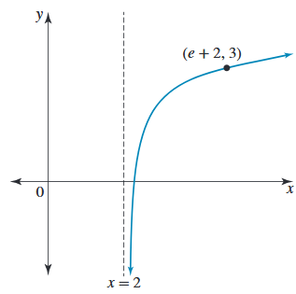

**Question 5 (3 marks)**

Solve the following equations for $x$. Show full algebraic reasoning.

$$3e^{2x}-5e^{x}-2=0$$

**Question 6 (5 marks)**

The graph of the function with the rule $y=3\log\left(x+1\right)+2$ intersects the axes at the point $(a,0)$ and $(0,b$). Find the exact values of $a$ and $b.$ Show full algebraic reasoning.

**Question 7 (8 marks)**

There are two species of insects living in a suburb: the *Asla bibla* and the *Cutus pius*. The number of *Ala bibla* alive at time $t$ days after 1 January 2000 is given by

$$N_{A}\left(t\right)=10 000+1000t, 0≤t≤15$$

The number of *Cutus pius* alive at time $t$ days after 1 January 2000 is given by

$$N_{C}\left(t\right)=8000+3×2^{t}, 0≤t≤15$$

1. (i) Show full reasoning that $N_{A}\left(t\right)=N_{C}\left(t\right)$ if and only if $t=3\log_{2}10+ \log_{2}\left(\frac{2 + t}{3}\right).$ (4 marks)
2. Solve the value for $t$ if $t=3\log_{2}10+ \log_{2}\left(\frac{2 + t}{3}\right).$ (2 marks)
3. It is found by observation that the model for *Cutus pius* does not quite work. It is known that the model for the population of *Asla bible* is satisfactory. The form of the model for *Cutus pius* is $N_{C}\left(t\right)=8000+c×2^{t}$. Find the value of $c$, correct to two decimal places, if it is known that $N_{A}\left(15\right)= N_{C}\left(15\right).$ (2 marks)

**End of Test**